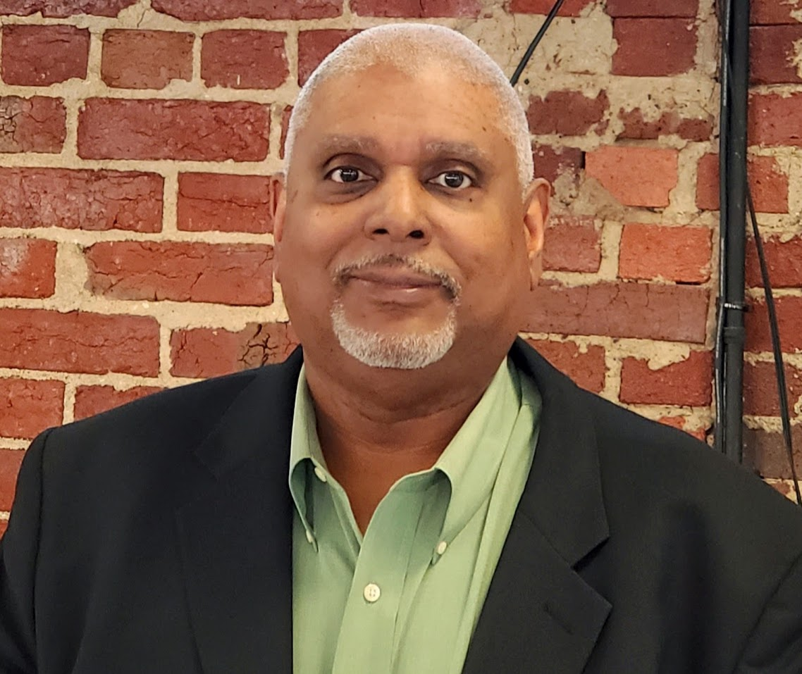

Name: Wayne Karl Driver

Email: wdriver@openhand-fred.org

Board Position: Member and Director of Technology

Introduction: I am a board member and the Director of Technology of Open Hand (OH) of Fredericksburg. My focus as a board member is to support OH through sound insight, progressive and innovative methods in organizational operations, the use of technology to better efficiencies, and increased visibility through social media.

Career History: I am presently an Information Technology Program Manager with a government agency in Washington, DC. I have over 35 years experience successfully working in all areas of technology in the private, public and non-profit sectors. Throughout my career, I have served in various roles such as a Manager, Consultant, Program Manager, Project Manager, Technical Lead, Church Administrator, Insurance Salesperson, and have served in several faith-based leadership roles. In my spare time, I am a genealogy and history enthusiast who has not only researched my own family history but numerous others. I have published a book, articles and have a blog sharing my findings.

Why Are You on the Board? I am on the Board because I was once an unmotivated young man who was fully capable of excelling in life, but needed the assistance of mentors and coaches. I was blessed to have these mentors and coaches to help me to become more ambitious and focused in school and life. Although I was a late starter in school and life, through the help of others, I have been able to accomplish more than I ever imagined. I want to do the same for youth like me and Open Hand is where I feel I can be most effective in serving and empowering the youth of Fredericksburg, VA and its surrounding counties.

