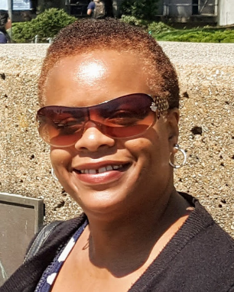

Name: Tamara X. Brown-Driver

Email: tdriver@openhand-fred.org

Board Position: Member and Grant Writer

Introduction: I am the Grant Writer of Open Hand of Fredericksburg. I became an OH Board Member and Grant Writer in March 2020. My concentration is researching, drafting, and submitting proposals and grant applications that support OH receiving grant funding. With grant funding, OH can continue to build on the legacy and devotion of empowering youth and their communities through our dedicated staff and programs.

Career History: I am presently a Grant Oversight Supervisor in government. With over 15 successful years of federal and state government experience, I have served in numerous positions to include Program Specialist, Mitigation Planner, Local Emergency Operation Planner, Recovery Specialist to name a few. In my career journey, I managed to briefly serve as a Grant Writer in the summer of 2005.

Why Are You on the Board? I am on the Board because I would love to see youth empowered to excel beyond their circumstances. I want them to know that the past does not have to define their future and that all things are possible with God. I would like to not only serve as OH’s Board Member and Grant Writer, but hopefully be an example and mentor in the life of the Open Hand of Fredericksburg Youth.

